Arithmetic Operations *

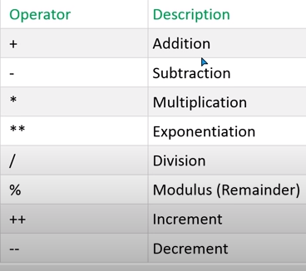

Number * Number
Returned a numeric value
console.log(2 * 2) //4
Number * string
If string number
Return a numeric value
Type-cast to string-number to number
console.log(2 * "2") //4
console.log(2 * "3" * 2) //12
console.log("3" * "2") //6
If normal string
Return a NaN
Type-cast to number as NaN
console.log(2 * "raj") //NaN
console.log(2 * "cha" * 2) //NaN
console.log("cha" * "ra") //NaN

number * boolean
Returned a numeric value
Type-cast boolean to number
console.log(2 * true) //2
console.log(2 * true * 2) //4
console.log(100 * false) //0

Number * undefined
Returned a NaN
Type-cast undefined to Number as NaN
console.log(2 * undefined) //NaN

Number * null
Returned a numeric value
Type-cast null to Number as 0
console.log(2 * null) //0

Number * array
Returned a numeric value
Type-cast array to Number
console.log(2 * [2]) //4
console.log(2 * ["4"]) //8

Sting * string
If string number
Returned a numeric result
Type-cast string value to number
console.log("100" * "30") //3000
If normal string
Returned NaN
Type-cast string to number as NaN
console.log("raj" * "chary") //NaN
console.log("100" * "raj") //NaN

String * boolean
If string number
True as 1 & false as 0
Returned a numeric result
Type-cast string and boolean to number
console.log("10" * true) //10
console.log("10" * false) //0
If normal string
Returned NaN
Type-cast string to number as NaN
console.log("raj" * true * "10") //NaN
console.log(true * "10" * "raj") //NaN
console.log("raj" * "10" * true) //NaN

String * null
If string number
Returned a numeric result
Type-cast string and null to number
console.log("10" * null) //0
console.log(null * "raj") //NaN
If normal string
Returned NaN
Type-cast string and null to number
console.log("10"* null * "raj") //NaN
console.log(null * "raj") //NaN

String * undefined
If string number
Returned NaN
Type-cast string and undefined to number, undefined as NaN
console.log("10" * undefined ) //NaN
console.log(undefined * "10") //NaN
If normal string
Returned NaN
Type-cast string and undefined to number, as NaN
console.log("raj" * undefined) //NaN
console.log(undefined * "10" * "raj") //NaN
console.log("10" * undefined * "raj") //NaN

string * array
If string numbers
Return a numeric value
Type-cast to string and array to number
console.log("10" * [1] ) //10
console.log( ["2"] * "10") //20
If normal string
Return NaN
Type-cast to string and array to number
console.log("raj" * ["2"]) //NaN
console.log([3] * "raj") //NaN

Boolean * boolean
Returned a numeric value
Type-cast to number
console.log(true * true) //1
console.log(true * false) //0

Boolean * undefined
Returned a NaN
Type-cast boolean and undefined to number
console.log(true * undefined) //NaN
console.log(false * undefined) //NaN

Boolean * null
Returned a numeric value
Type-cast boolean and null to number
console.log(true * null) //0
console.log(false * null) //0
Boolean * array
Returned a numeric value
Type-cast boolean and array to number
console.log(true * [4]) //4
console.log(true * ["2"]) //3

Undefined - undefined
Returned a NaN
Type-cast undefined to number
console.log(undefined * undefined) //NaN

Undefined - null
Returned a NaN
Type-cast undefined and null to number
console.log(undefined * null) //NaN

Null - null
Returned a numeric value
Type-cast null to number
console.log(null * null) //0

Array - array
Returned a numeric value
Type-cast array to number
console.log([1] * [10]) //10
console.log([10] * ["10"]) //100
console.log(["12"] * [2]) //24
console.log(["2"] * ["10"]) //20

